



Index

1. Software description **2**

2. Software installation **2**

2.1. MacOS Catalina 2

2.1.1. Octave installation 2

2.1.2. Python installation 5

2.1.3. SonoUno installation 6

2.1.3.1. Installation with pip 6

2.1.3.2. Installation from source 7

2.1.4. Run the software 9

2.1.5. Possible problems 10

3. Import a file to the software **11**

# 1. Software description

SonoUno is a sonification software for two column tables of astronomical data. The software is being developed based on the study of other software (Sonification Sandbox, MathTrax and xSonify) and standards of accessibility like the ISO 9241-171:2008 (Guidance on software accessibility). In order to develop the first approach of graphical user interface, we perform a theoretical framework based on bibliography of user cases, focused on blind and visual impairment people.

The develop language is Python and we use modular design, in order to do collaborative work. The sonoUno now is multiplatform, tested on windows 10, Ubuntu 16.04 and Mac High Sierra; the development team work continuously to maintain this benefit. The principal goal of the SonoUno is to allow the user to open data files (txt or csv extension), reproduce the plot and sonification of the data. At the moment, the sonification is perform by variation of pitch in different instruments.

Additionally, SonoUno allow to select a specific range of data on the ‘x’ axis, mark and save point of interest in the data, apply predefined mathematical functions (for example, logarithm and square) and manipulate the data arrays with an Octave interface. In the section settings, the user can configure the plot and change between several predefined instruments (acoustic piano, clavinet, celesta and tubular bells, between others). We expect to include more sound configurations shortly.

Finally, the software allows the user to save the sound, the plot, a text file with the points marked on the data and a csv file with the plotted data.

# 2. Software installation

## 2.1. MacOS Catalina

### 2.1.1. Octave installation

In this instructive we install octave with homebrew, but you can install it with other package manager for Mac OS. We don’t use the dmg package because it can be open from terminal.

1. First, we check if we have brew installed (Image 1):
   1. brew update



*Image 1 - Shown the command brew update, in this case brew is up to date, if not the terminal shown some other messages indicating the actualization.*

1. If that line give an error, you can install brew with (Image 2, Image 3, Image 4):
   1. /bin/bash -c "$(curl -fsSL <https://raw.githubusercontent.com/Homebrew/install/master/install.sh>)"

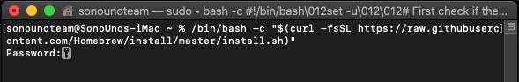

*Image 2 - Brew installation on MacOS with a command extracted from “https://brew.sh/”. After press enter the terminal ask for the user password.*

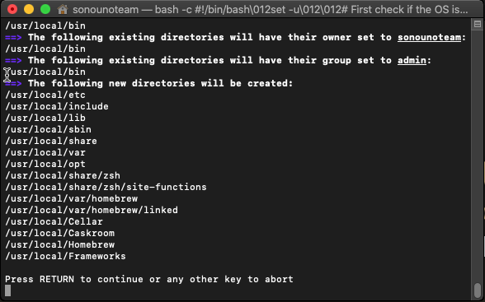

*Image 3 - After enter the user password the installation process describe which path will be created or modified and ask if the user want to continue or abort.*

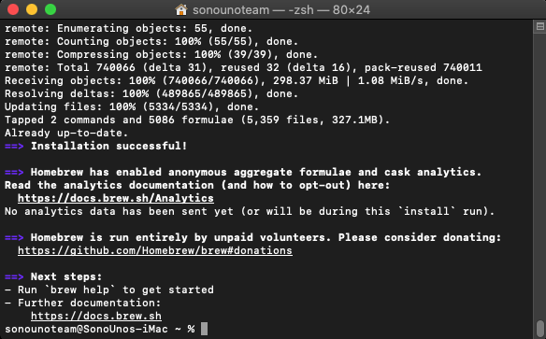

*Image 4 - If the installation was successfully, the terminal inform that to the user and show some other recommendations.*

1. You can try the command ‘brew help’ to check if brew is installed (Image 5).

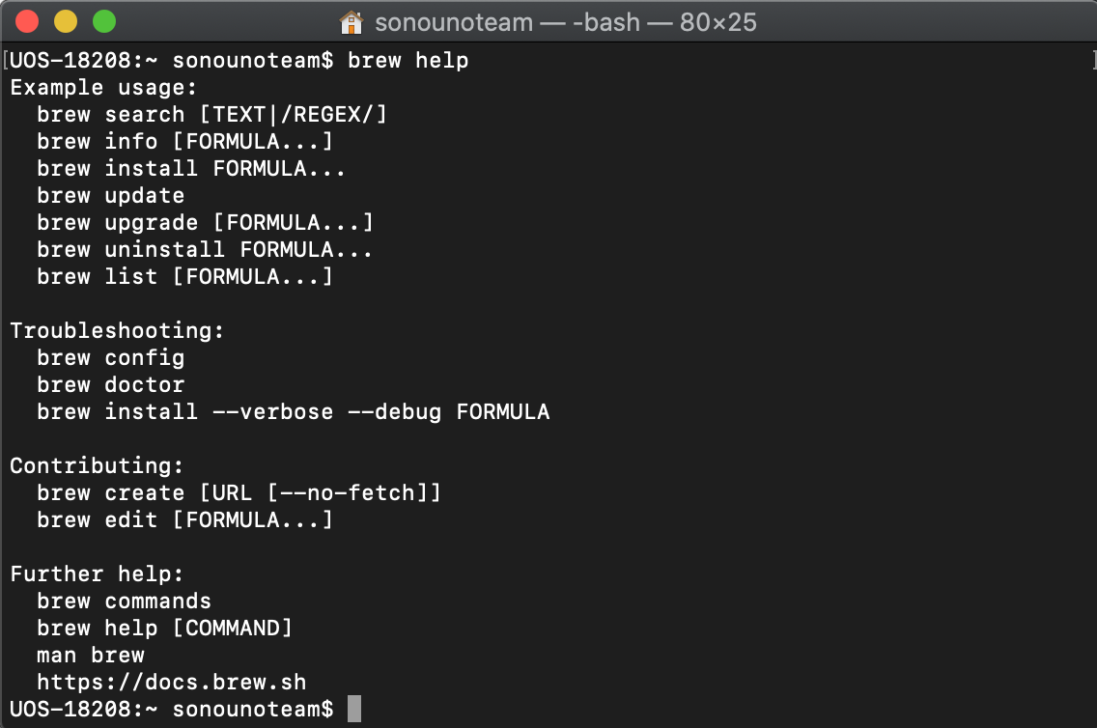

*Image 5 - Shown the result of the command brew help, the message contain an example usage section, troubleshooting, contributing and further help.*

1. Now we can run the next command to install octave (Image 6, Image 7):
   1. brew install octave

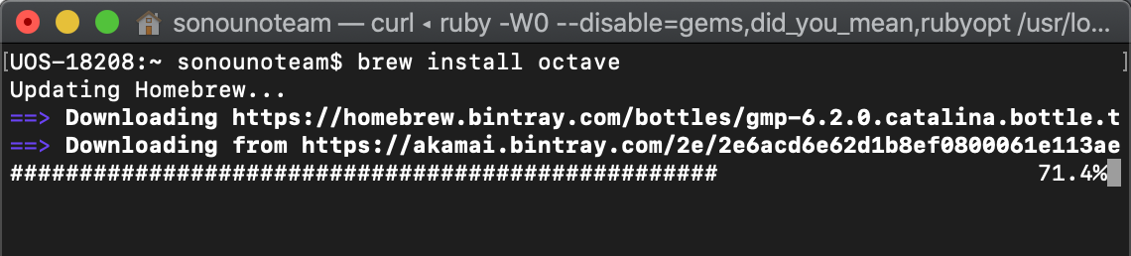

*Image 6 - Shown the command brew install octave and the first part of the installation when brew is updating itself.*

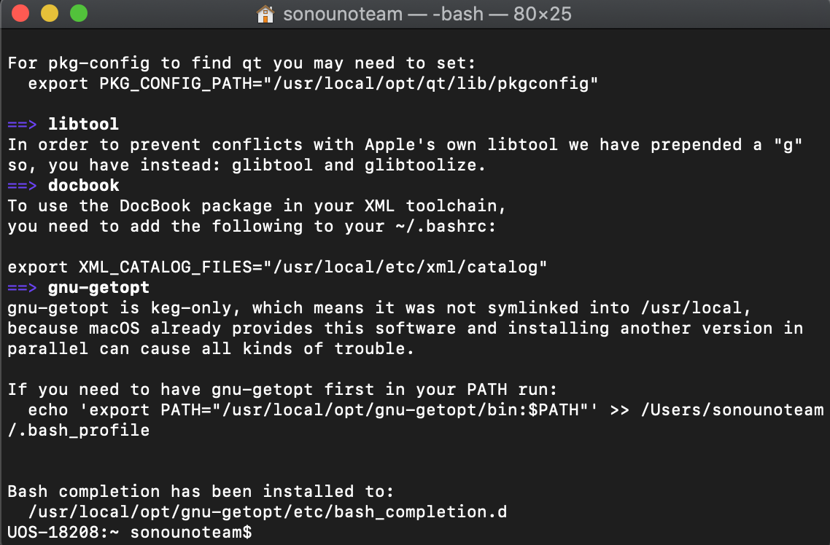

*Image 7 - Shown the last part of the octave installation.*

1. To test if octave is installed correctly you can run on terminal the command ‘octave’, if the program is installed, the octave terminal is opened on the same windows (Image 8).

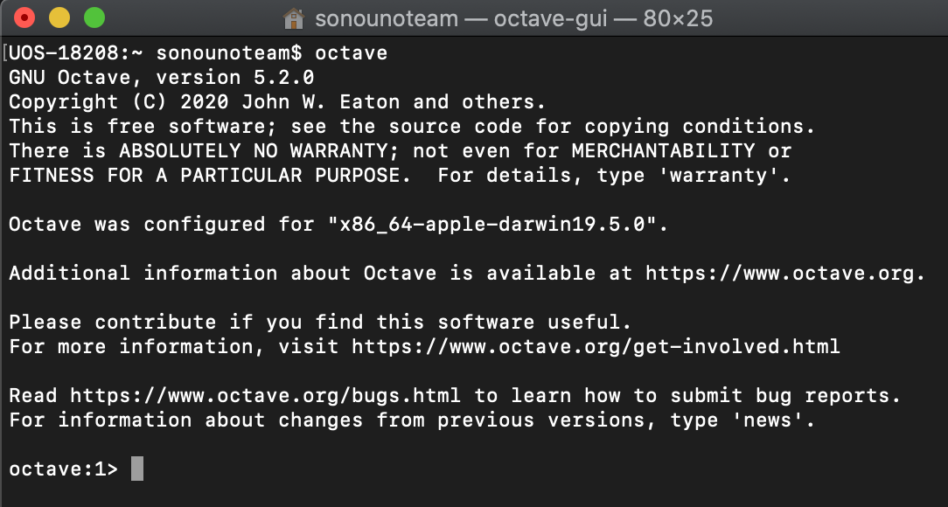

*Image 8 - Shown the octave command line opened with the command octave.*

### 2.1.2. Python installation

If you have python installed on the computer you can skip this section. If not, or you are not sure, follow the next steps.

1. Go to the terminal and execute the ‘python3’ command (Image 9):

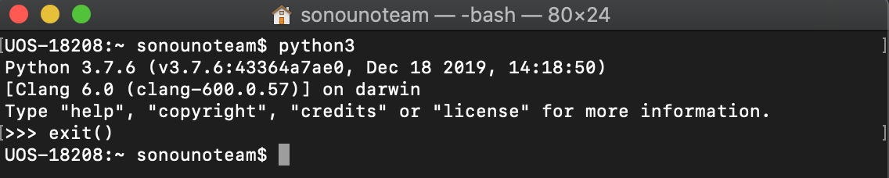

*Image 9 - MacOS terminal with the command python executed.*

1. If the version is 3.7.x, you can continue with the following steps. If not, you must update or install python 3.7 in the operating system, using the installer on <https://www.python.org/ftp/python/3.7.7/python-3.7.7-macosx10.9.pkg>
2. After install python, check if you have pip installed on your system with the next command (Image 10):
   1. python3 -m pip -V

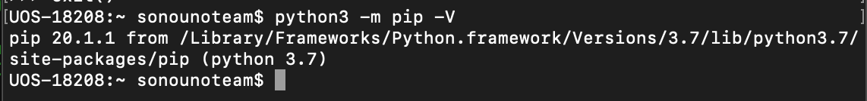

*Image 10 - Show the execution of "pip -V" command and the answer that pip is installed on the system.*

**NOTE**: To install pip you can try “easy_install pip” or “sudo easy_install pip” if admin privilege is needed. Or download python package from the website and install it.

1. Once that we checked that we have python 3 and pip installed (is called python3 in this instructive), we can proceed with the next step.

### 2.1.3. SonoUno installation

#### 2.1.3.1. Installation with pip

After you install python3 and verify that pip is installed, you can write the next commands on terminal to install (Image 11) and use sonoUno (Image 12):

1. sudo python3 -m pip install -U sonoUno

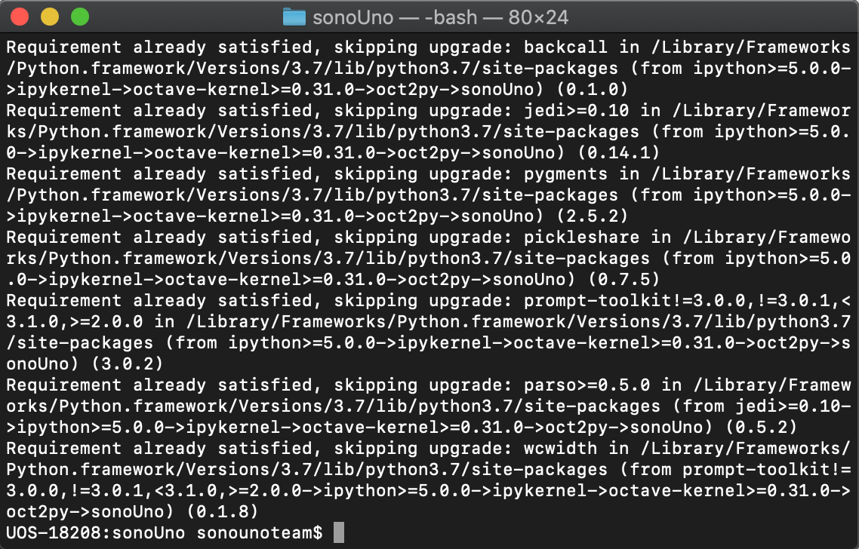

*Image* *11* *- Shown the last part of the sonoUno installation.*

1. sonoUno

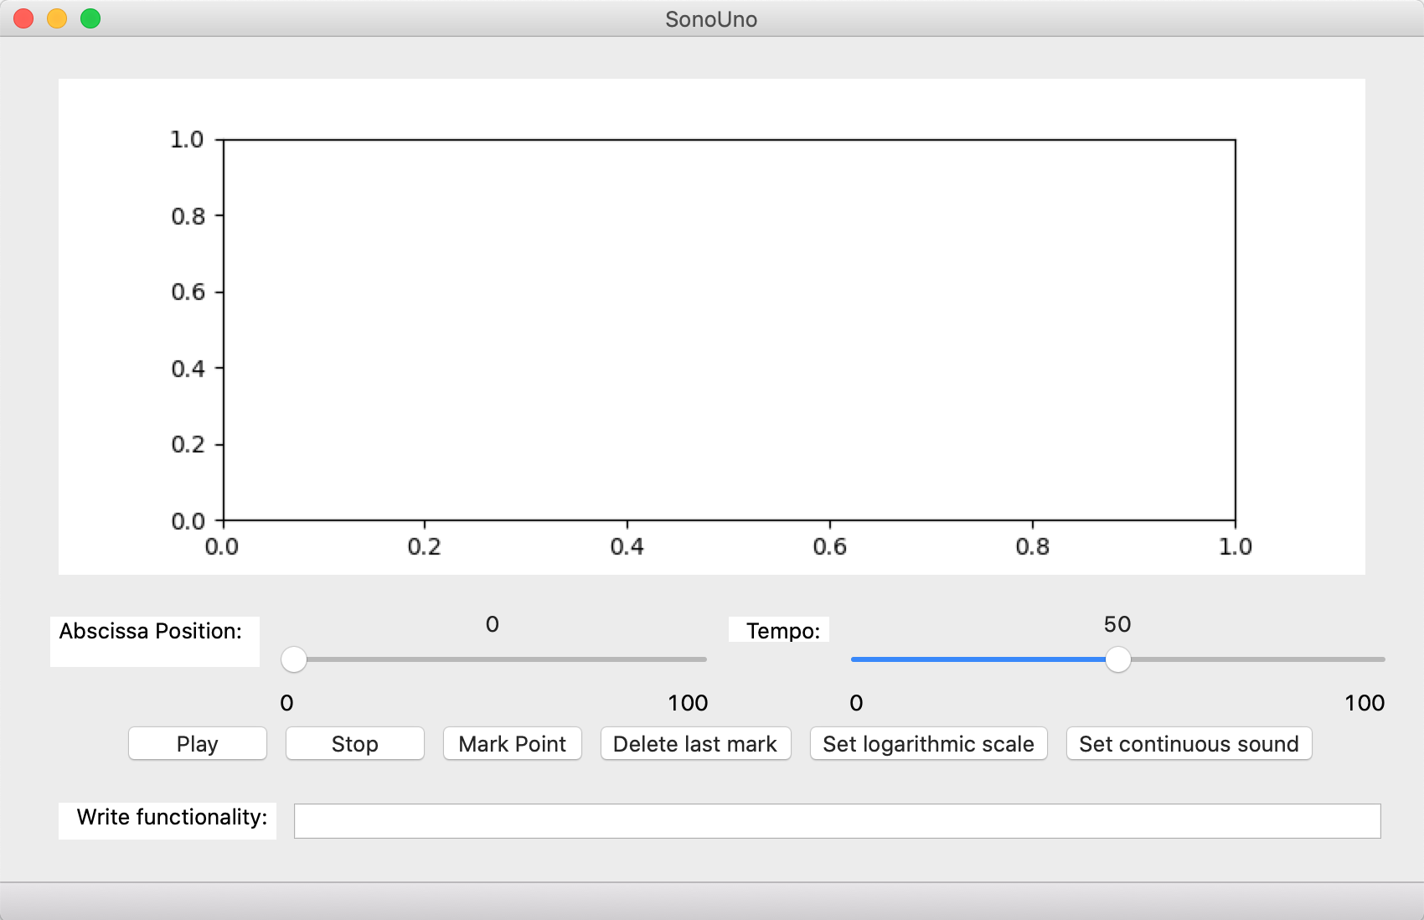

*Image 12 - Shown the sonoUno display opened with the command ‘sonoUno’ after its installation with pip.*

The last command ‘sonoUno’ directly open the software. If you can’t install the software with sudo, you can’t execute the software with the command ‘sonoUno’. In that case, you have to search the sonoUno executable in your system, you can write sonoUno on Finder and open the sonoUno executable there.

#### 2.1.3.2. Installation from source

Here we explain how to install each one of the libraries to run sonoUno from source.

1. Install wxPython Phoenix with the next command (Image 13):
   1. python3 -m pip install -U --user wxPython

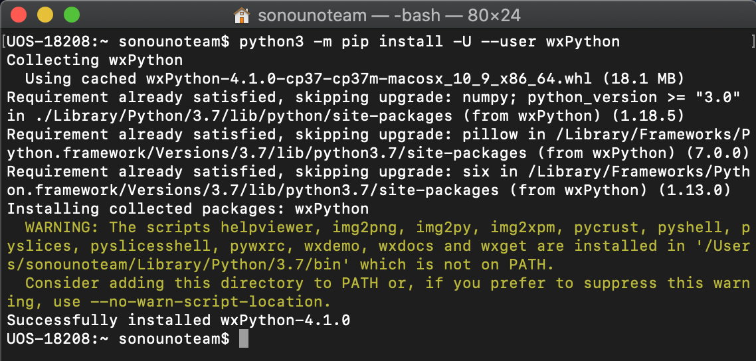

*Image 13 - Installation of wxPython with the previous command.*

**NOTE**: The installation can take several minutes, be patient. If the installation takes more than 30 minutes cancel the process (Ctrl+C) and execute the command once again. The aspect of the installation, can be seeing in Image 13.

1. Install matplotlib (Image 14):
   1. python3 -m pip install -U --user matplotlib

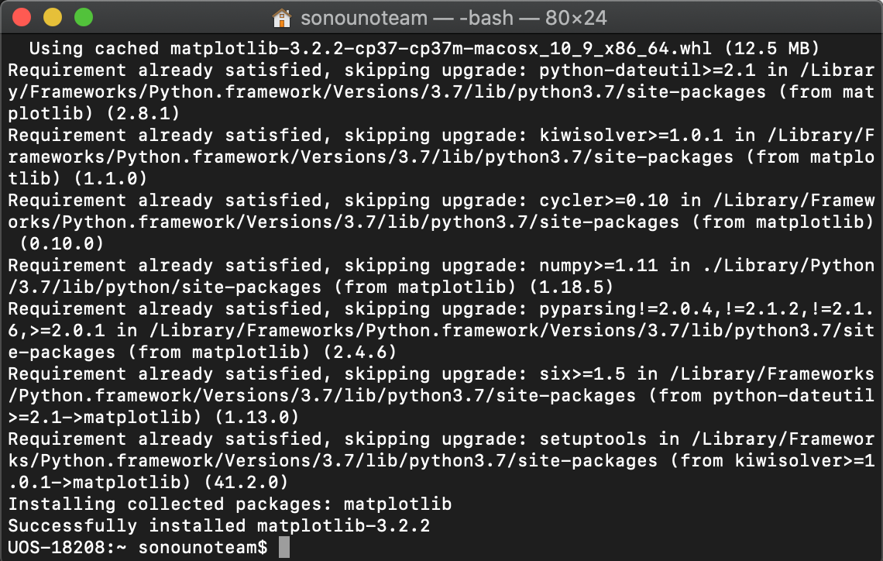

*Image 14 - Last part of the installation of matplotlib with the previous command.*

1. Install pandas (Image 15):
   1. python3 -m pip install -U --user pandas

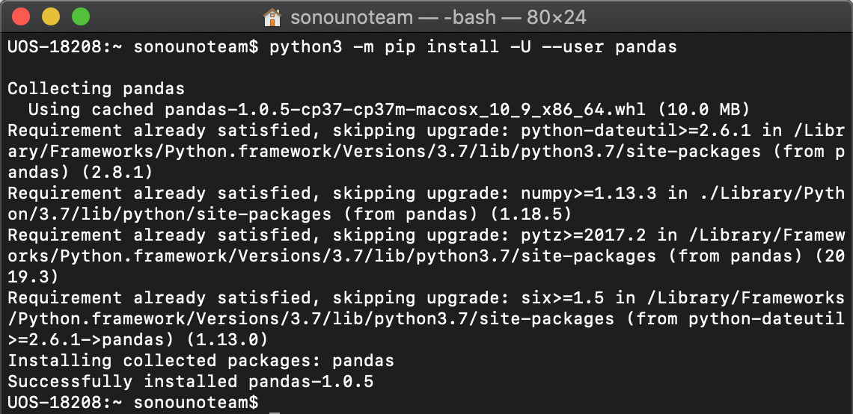

*Image 15 - Installation of pandas with the previous command.*

1. Install numpy (Image 16):
   1. python3 -m pip install -U --user numpy

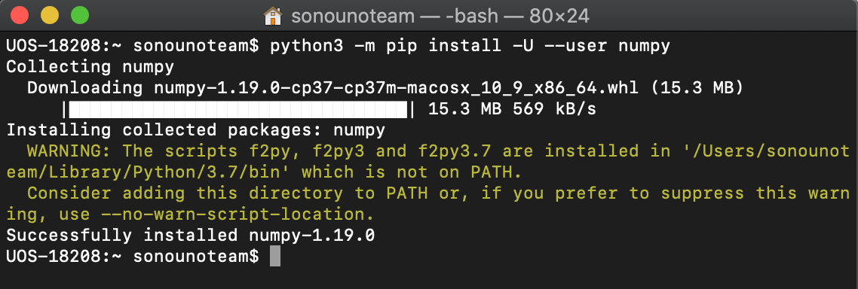

*Image 16 - Installation of numpy with the previous command.*

1. Install pygame (Image 17):
   1. python3 -m pip install -U --user pygame

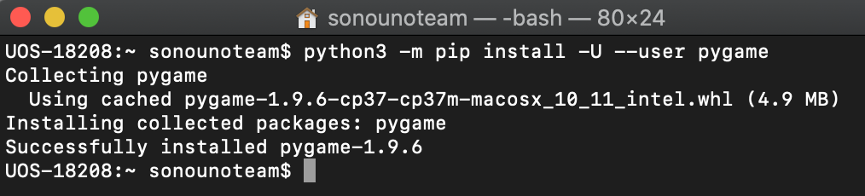

*Image 17 - Installation of pygame with the previous command.*

1. Install oct2py (Image 18):
   1. python3 -m pip install -U --user oct2py

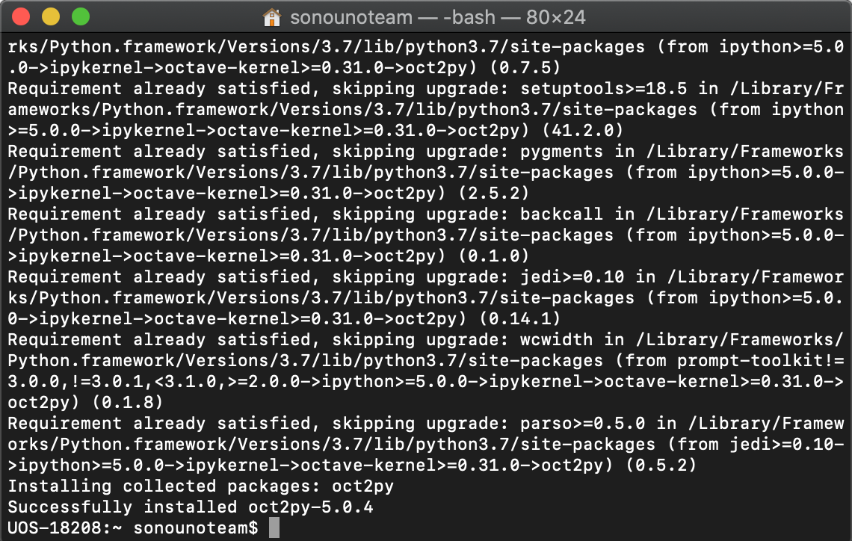

*Image 18 - Last part of the installation of oct2py with the previous command.*

1. Try that ‘oct2py’ was installed correctly with python3 on the terminal following the next steps:
   1. Open python3 on the terminal with the command:
      1. python3
   2. Import ‘octave’ from ‘oct2py’ library with the command:
      1. from oct2py import octave
2. If ‘octave’ is imported without problems (Image 19), type ‘exit()’ and jump to ‘Run the software’ section of this manual. On the other hand, if an error appears contact the development team.

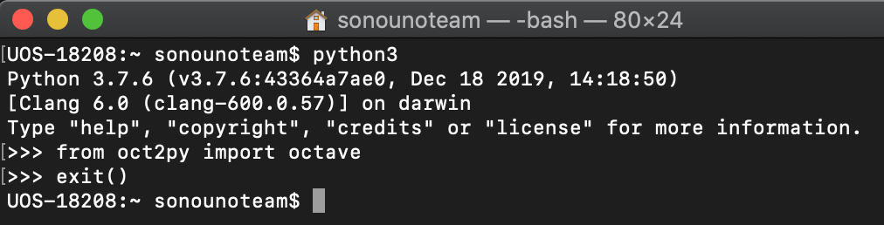

*Image 19 - Shows the oct2py library importation command without errors.*

**NOTE: if any of the libraries is missing, the software does not run. The installation can take several minutes.**

### 2.1.4. Run the software

1. Unzip the file, if it is compressed. If you want to clone from github use the next line:
   1. git clone https://github.com/sonoUnoTeam/sonoUno.git
2. Open a terminal and go to the software folder. Probably you have more than one folder before you can run SonoUno. To check in which folder is sonoUno, use the command “ls” (Image 20). The sonoUno must be among the files and the manual in the folder.

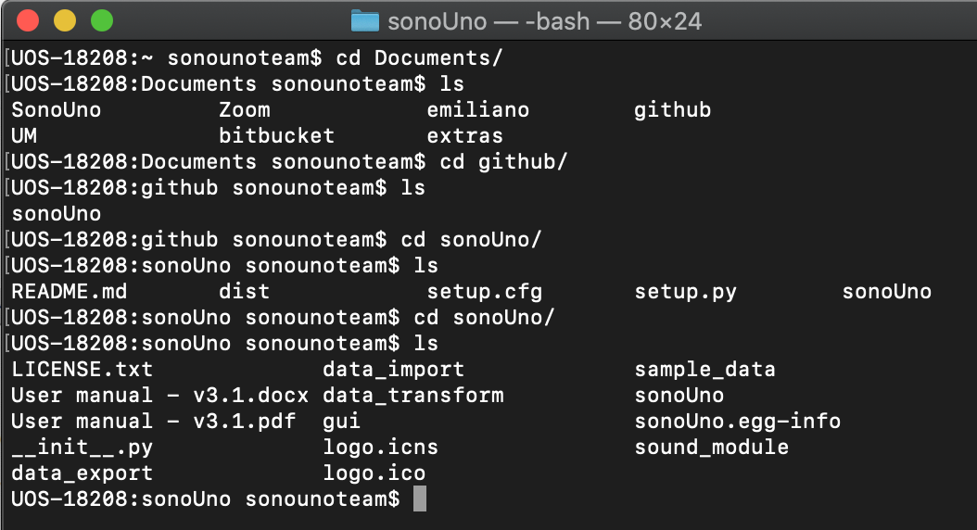

*Image 20 - Aspect of the sonoUno folder on the command window.*

1. Once you are sure that you are at the right folder, make:
   1. python3 sonoUno
2. A window must be open (Image 21), if that is the case, the soft is ready to be used.



*Image 21 - SonoUno main window on Mac.*

### 2.1.5. Possible problems

Sometimes, after the updates of octave or xcode, even after python updates, the dependencies can be change or in some cases can be broken. In that situacion the software stop running and through different errors, like the libraries are not found or errors related with octave.

You have to check which python you are using and specify on the system the path to the specific python. Clean and erase the python that you don’t use is a very good practice.

If you have problems with octave you can try with ‘brew reinstall octave’, or uninstall and install it again.

# 3. Import a file to the software

Once the software is installed, and you can open it, you are ready to try your first dataset. The initial window of the software only shows the plot and the reproduction options of the data (Image 21), the other functionalities are hide and were shown in the user manual. This design was based on a user cases study and ISO standards.

In order to probe the SonoUno, you have to import a data file. If you don’t have a data file, the installer provides a folder named “data” with simple functions on the installation directory or you can download this folder from github.

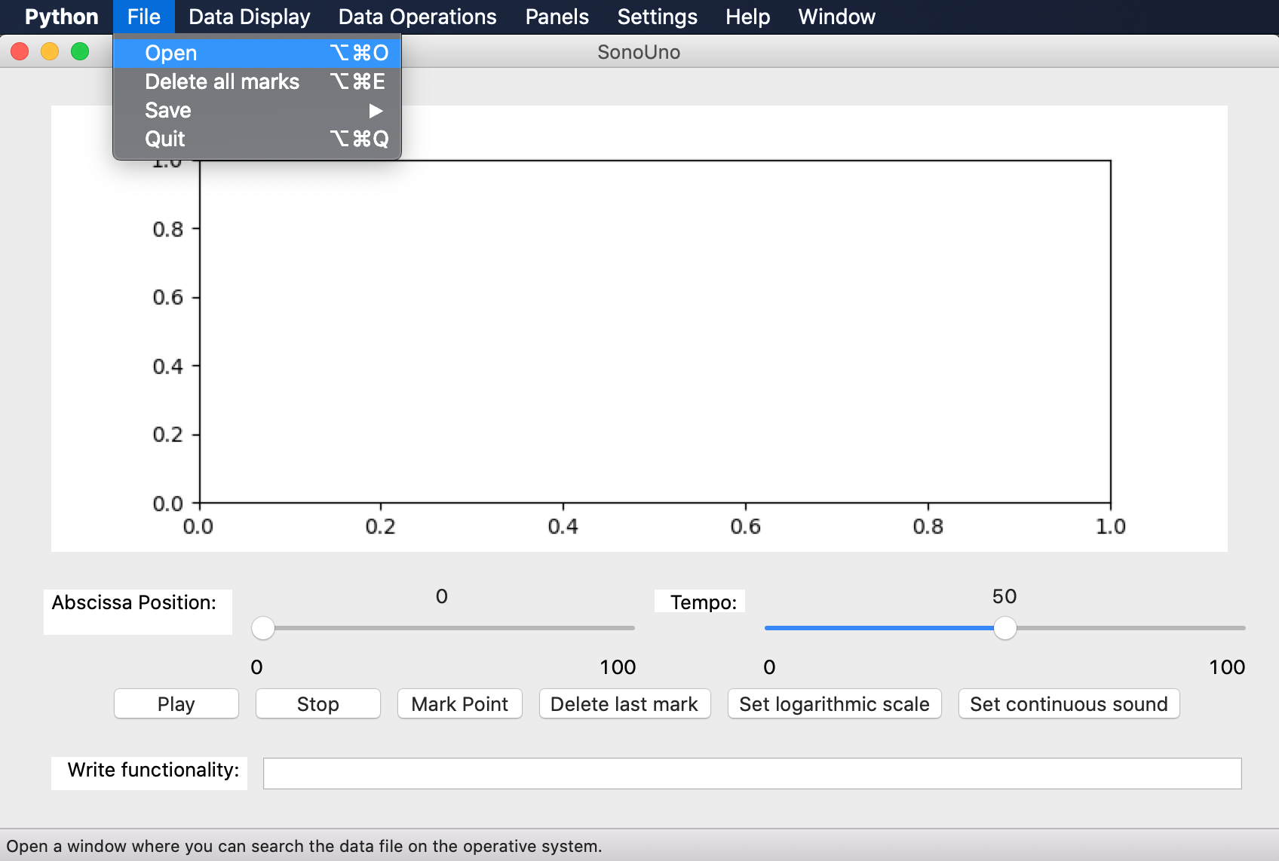

*Image 22 - Open a file: choose the item Open on the menu File.*

The first step to open a data file, is to select the item Open on the menu File (Image 22). This action shows a new window of the file system of the computer, where you can choose the data file. Once you have the data file selected, press the button “Open” (Image 23).

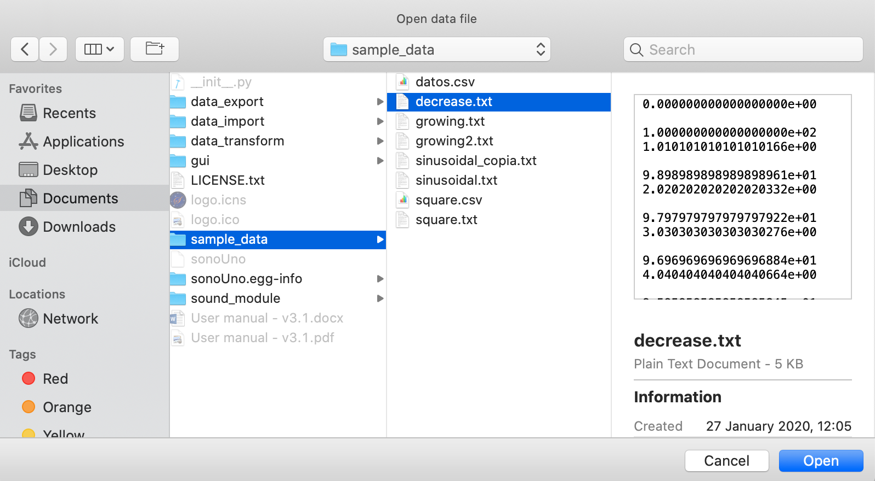

*Image 23 - New window of the file system of the computer.*

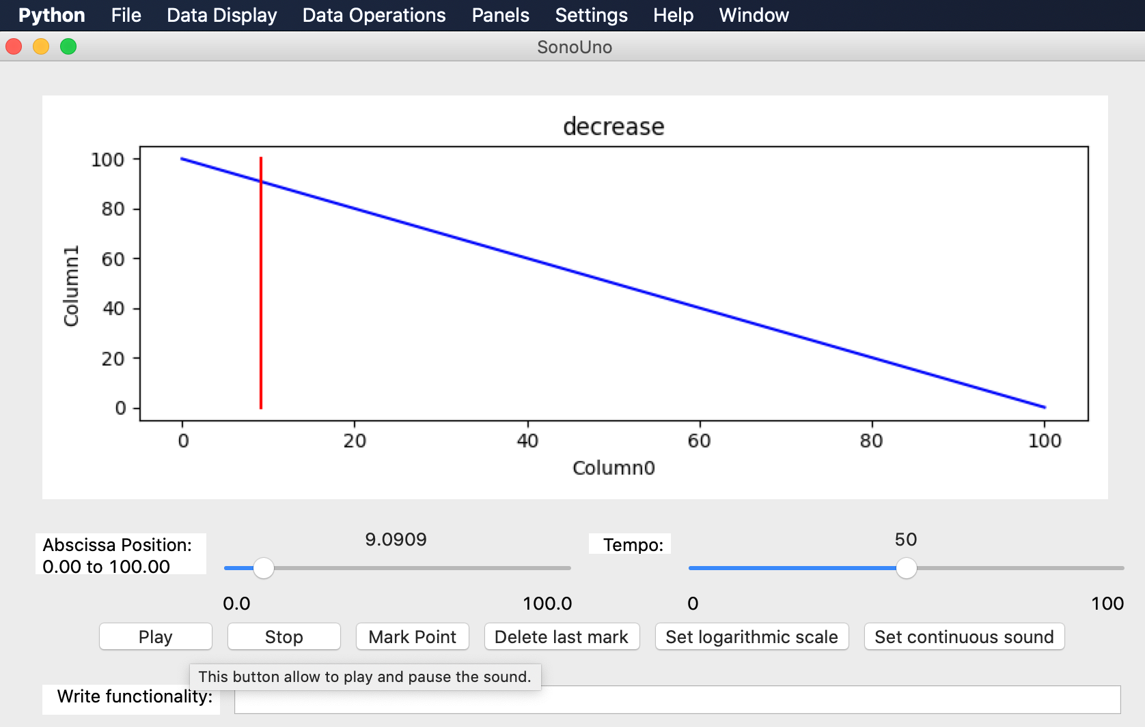

*Image 24 - Reproduction of the data file after press the button Play.*

After open the data file, the SonoUno show the plot and is ready to reproduce the sound. In order to reproduce it, you have to press the button Play (Image 24). If the software installation is correct, you must listen a pitch variation and see a red vertical bar moving through the data, this bar indicate the position of the data that is been sonificated.

If the software doesn’t produce sound, check the speakers or headphones on your computer. If the problems continue or you have another problem, inform this to the developer team.